|  |  |
| --- | --- |
| Research Study Monitor Remote Epic Access | |
| FACILITY: | UMMS |
| ROLE: | Research STUDY MONITORS |

**Remote Access Request for Research Study Monitors**

Research study monitors requiring remote Epic Portfolio access can achieve this access through PortfolioMD. The study monitors can send the request through the PortfolioMD portal directly. The monitor must provide the appropriate information to identify the research protocol that the subjects have been associated to within Epic Portfolio by the research staff using Epic Research security.

The link below it to be used to access the PortfolioMD by the research study monitor

**Link**: [UMMS Self Service Portal 2.0 NOT Logged In - IT OOTB (Access Request)](https://cher-prd-web.umms.umm.edu/CherwellPortal/ITOOTBAccessRequest?_=6ffbaafc#0)

Select the PortfolioMD View Only box

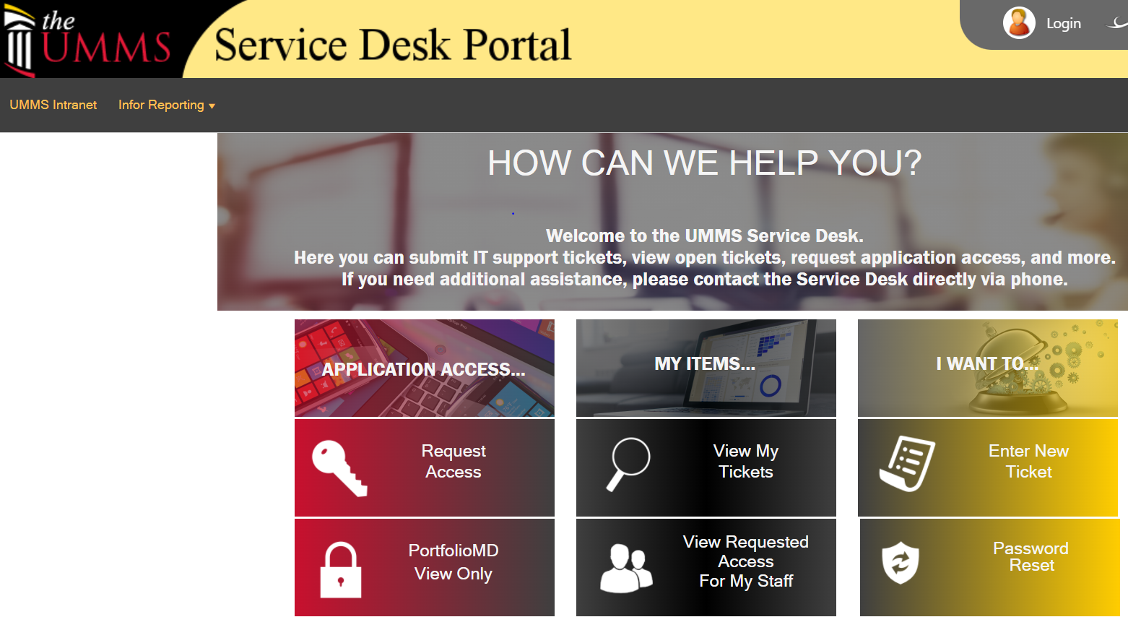 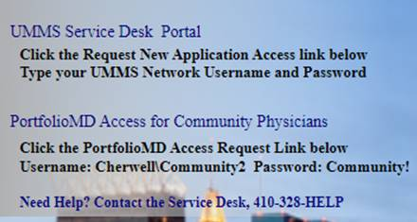

Username:  Cherwell\Community2

Password:  Community!

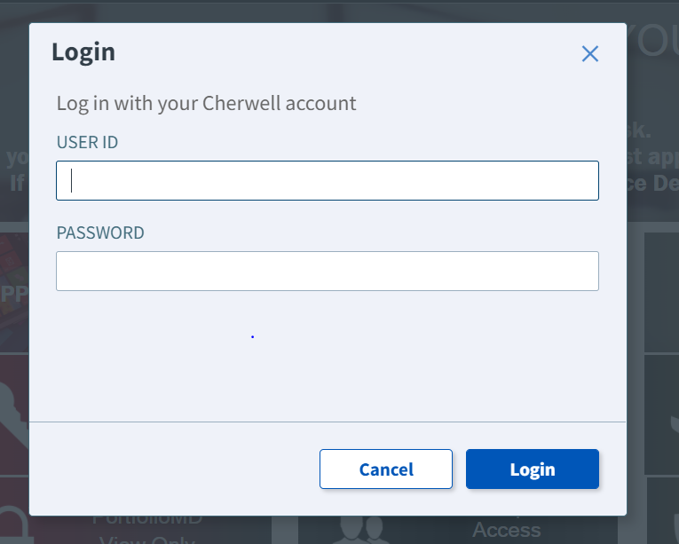

**Study Monitor completion guide**:

1. Fill in Name First, Middle, Last
2. Place a month (01-12) in the DOB Mo section
3. Place a Day (1-31 *month dependent*) in the DOB Day section
4. Place the last 4 digits of your SSN for security access
5. Select User role drop down as **Research monitor**
6. Study Identification Number section will appear: this section must include the Epic (RSH) research record identification naming for the protocol to be monitored. (Most protocols will start with HP#000 for this ID section)

**Please secure this naming convention from the study coordinator prior to requesting access.**

1. Add contract expiration date ( < one year)
2. Add the monitor direct email:

* **Please assure email is correct as all communication will come through this email.**

1. **Complete Practice Name**: the department being monitored (e.g. Transplant, Trauma, Pulmonary,etc.)
2. **Practice Address**: Place the address of the PI and Study coordinator along with their names and contact information
3. Include the research University of Maryland Department phone number and fax

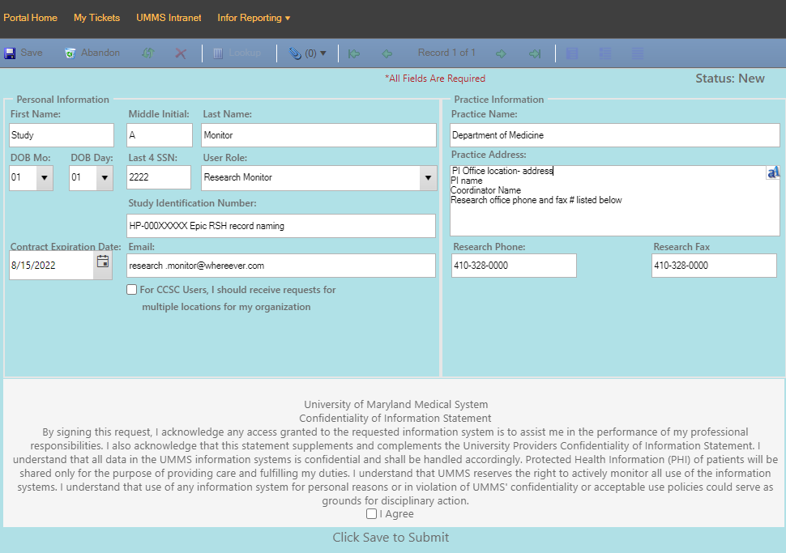

Study Monitor will receive email with login information once access request has been approved